**Assignment 3 : Retrieve data using Group By clause**

Sample table1: Department

-dept_id

-dept_name

Sample table2: Employee

-emp_id -dept_id

-mngr_id -emp_name

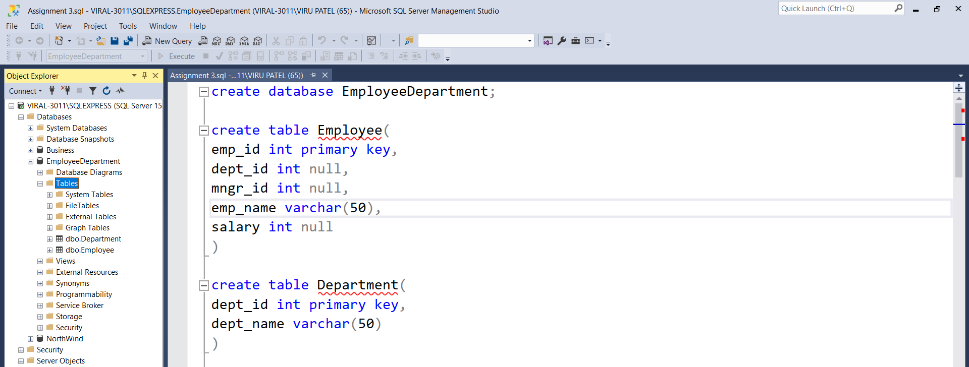-salary

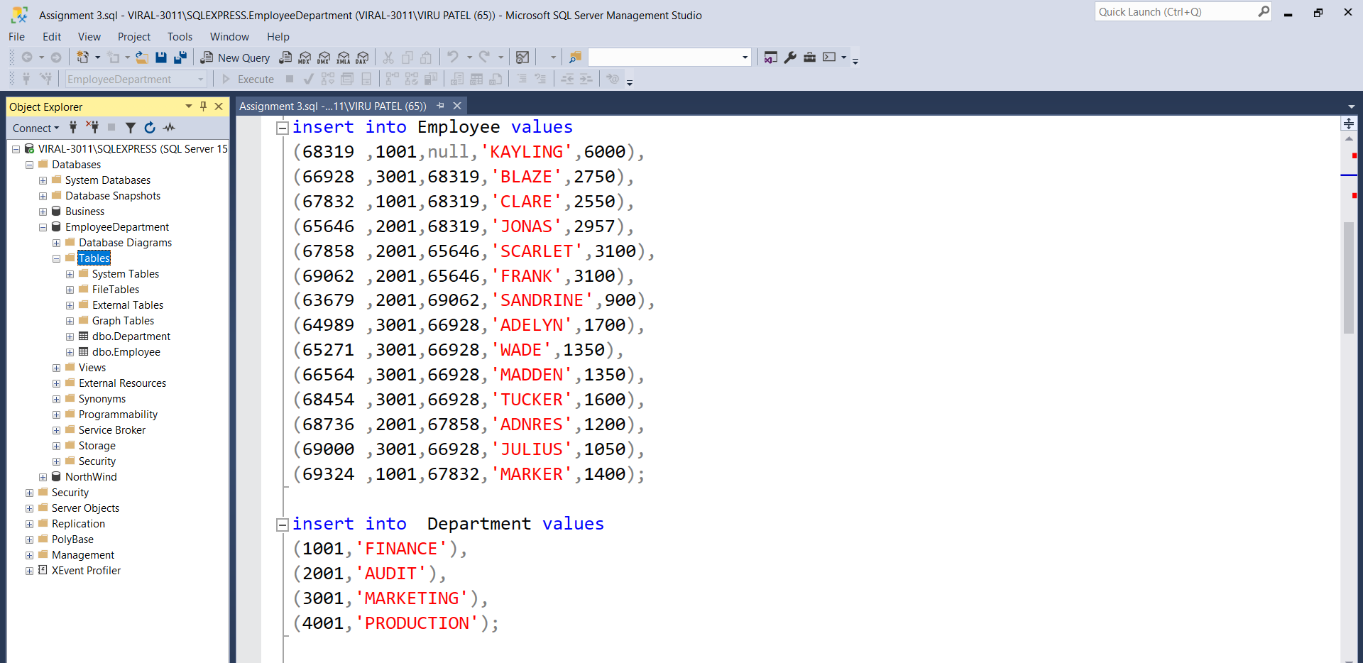Insert data into tables:

Query 1. write a SQL query to find Employees who have the biggest salary in their Department:

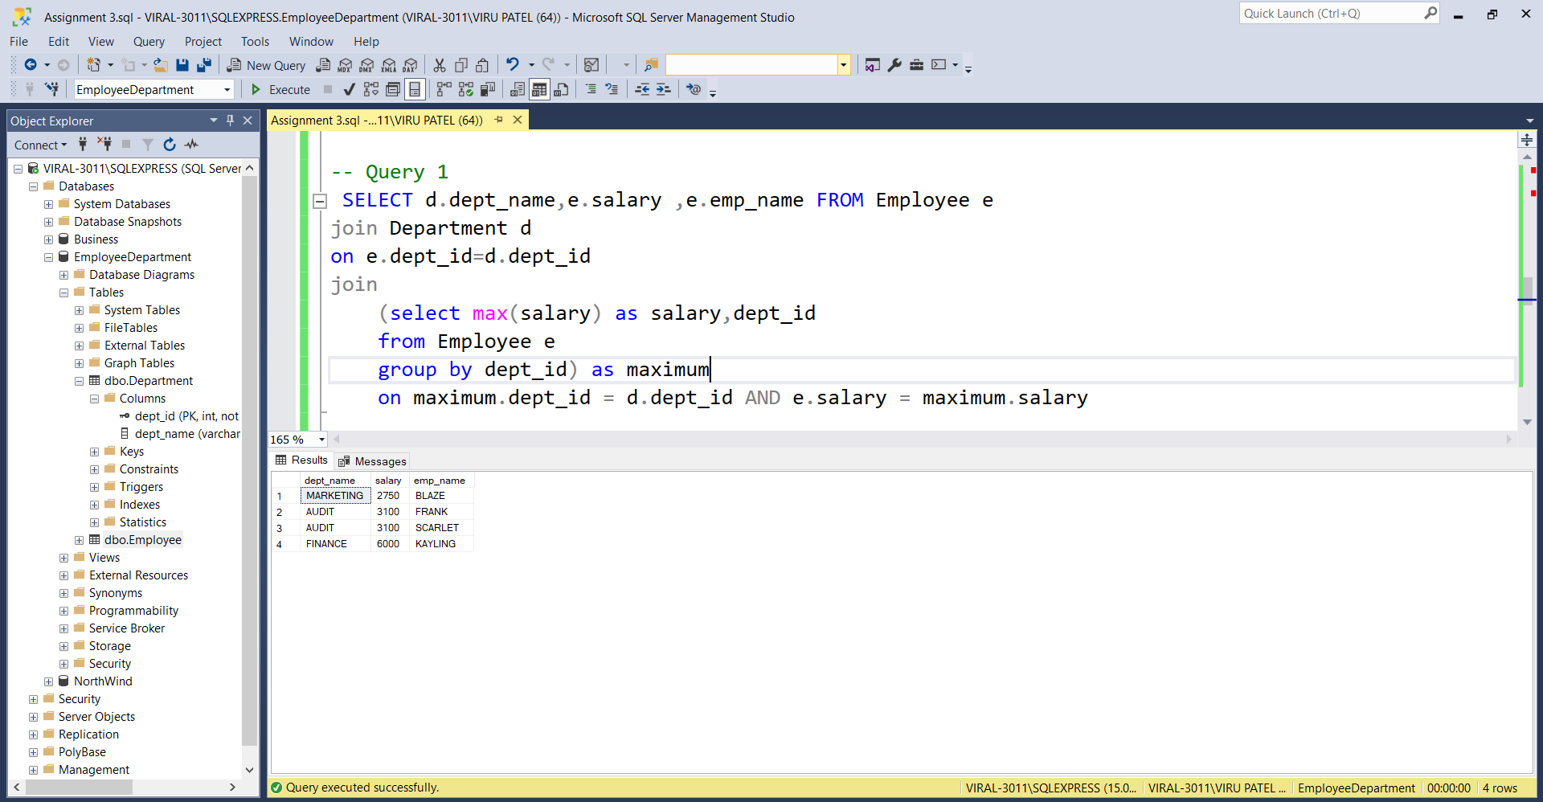

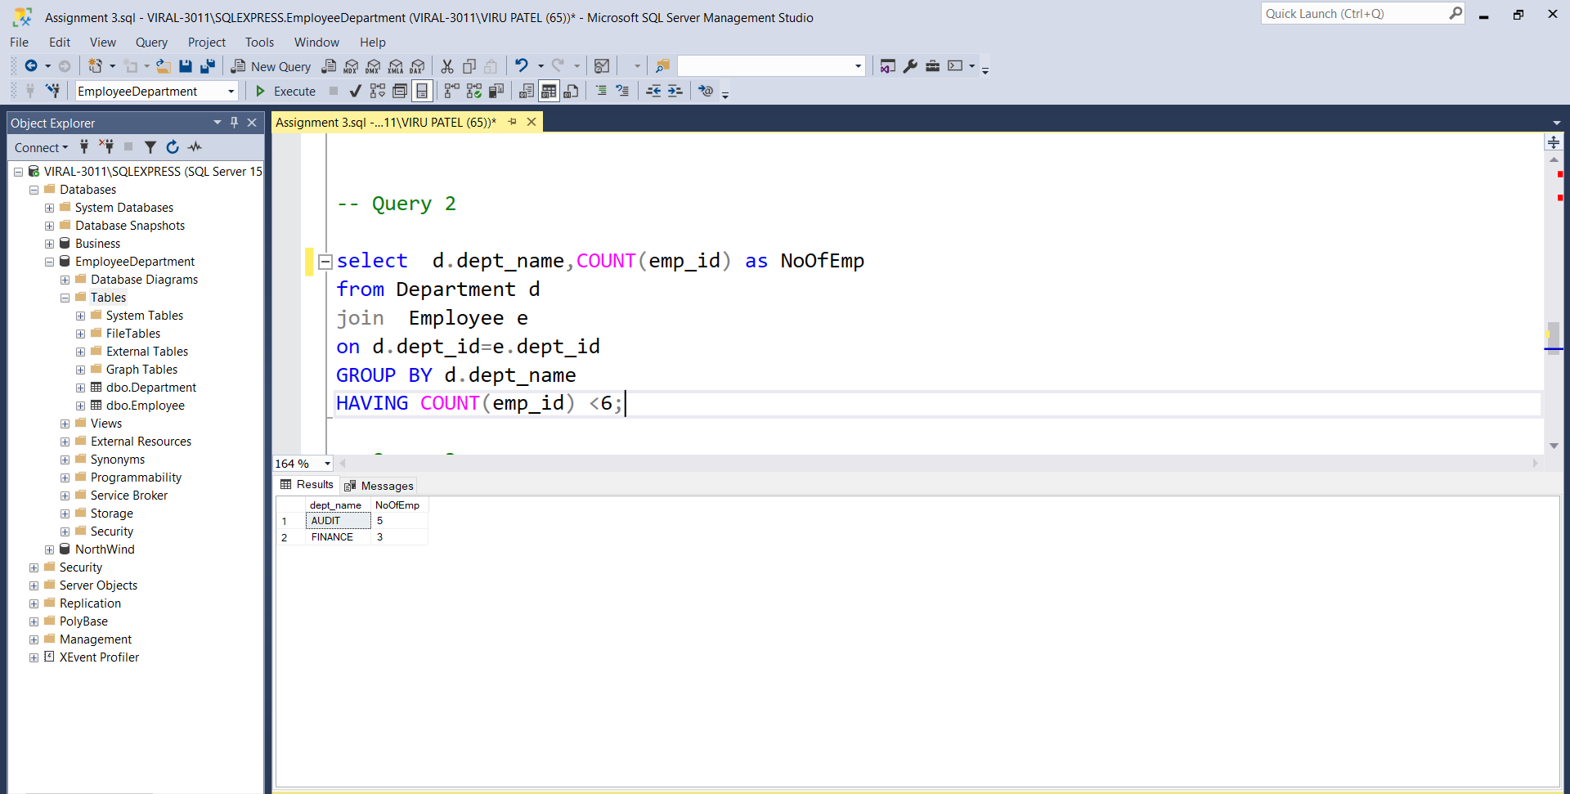Query 2. write a SQL query to find Departments that have less than 3 people in it.

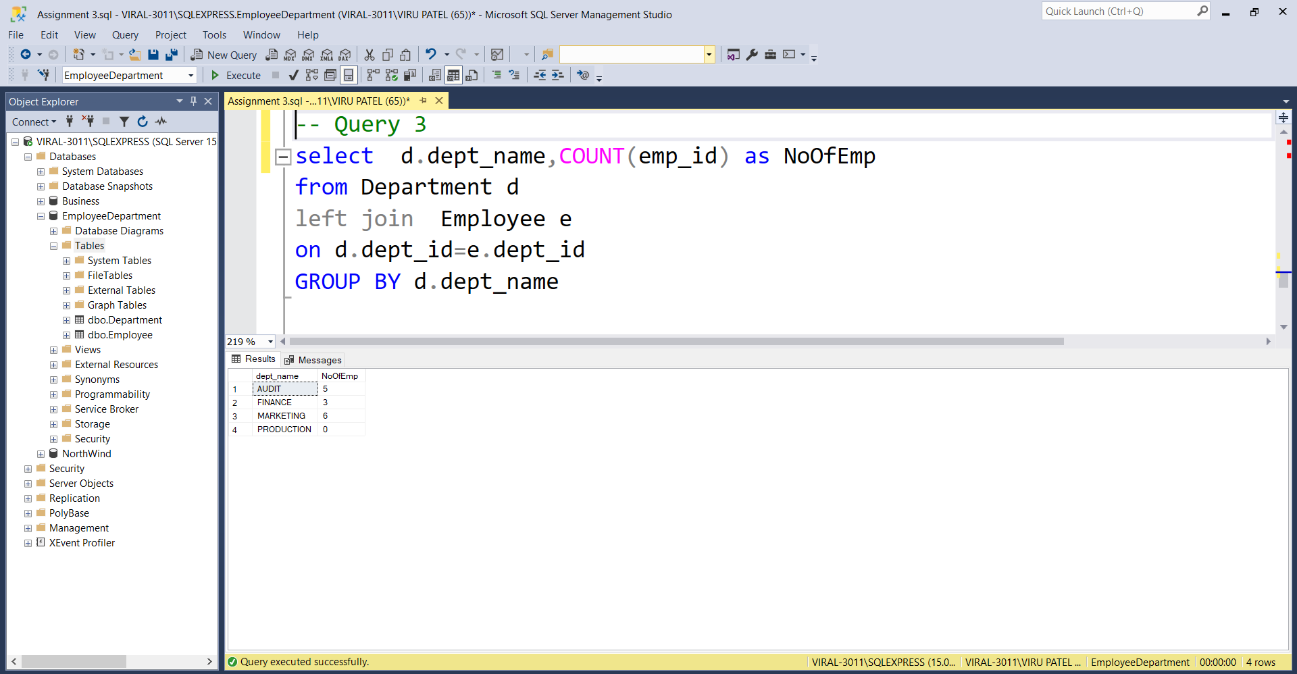Query 3. write a SQL query to find All Department along with the number of people there.

Query 4. write a SQL query to find All Department along with the total salary there.

